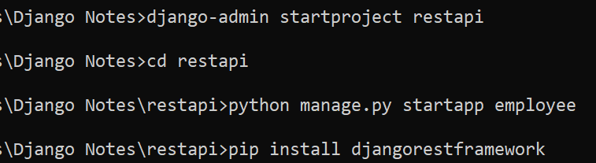

Django-admin startproject restapi

Cd restapi

Python manage.py startapp employee

Open project in vs code

Create model in models.py :

from django.db import models

# Create your models here.

class Employee(models.Model):

   eid = models.AutoField(primary_key=True)

   name = models.CharField(max_length=50)

   salary = models.IntegerField()

   department = models.CharField(max_length=50,choices=

                                 (('IT','IT'),

                                  ('HR','HR'),

                                  ('MANAGER','MANAGER')))

   active = models.BooleanField(default=True)

   register_date = models.DateTimeField(auto_now = True)

create serializers.py at application level (in employee folder)

from rest_framework import serializers

from employee.models import Employee

class EmployeeSerializer(serializers.ModelSerializer):

   class Meta:

      model = Employee

      fields = "__all__"

create class based view in views.py

from django.shortcuts import render

from rest_framework import viewsets

from employee.models import Employee

from employee.serializers import EmployeeSerializer

# Create your views here.

class EmployeeViewSet(viewsets.ModelViewSet):

   queryset=Employee.objects.all()

   serializer_class = EmployeeSerializer

create employee_urls.py at application level (in employee folder)

from django.urls import path,include

from rest_framework import routers

from employee.views import EmployeeViewSet

from employee.models import Employee

router=routers.DefaultRouter()

router.register('employees',EmployeeViewSet,basename='Employee')

urlpatterns = [

    path('',include(router.urls)),

]

Include above file in urls.py of project

from django.contrib import admin

from django.urls import path,include

urlpatterns = [

    path('admin/', admin.site.urls),

    path('api/',include('employee.employee_urls')),

]

Runserver

Goto browser and <http://127.0.0.1:8000/api/employees/>

pip install django-cors-headers

Add f